APPLICATION FORM AND CONDITIONS FOR THE USE OF PLAYING FIELD

Introduction

Cromhall Parish Council leases the playing field adjacent to St Andrews C of E Primary School in Church Lane, Cromhall, Wotton under Edge, Gloucestershire from The Tortworth Estate. The field is predominately used by the school as an outside play resource. However, the Parish Council does occasionally allow the appropriate use of the playing field by for local residents for events such as village fetes and fairs and as off road parking for private cars associated with large parish weddings and christenings.

The Parish Council has a legal responsibility and duty of care to ensure the upkeep and security of the playing field during its usual accepted daily functions. Under the terms of the lease, the Parish Council has certain restrictions and obligations which may necessitate special terms, including insurance cover.

Anyone who wishes to make use of this facility is required to obtain prior approval from Cromhall Parish Council. A booking form (see pages 4-5) must be completed and sent to Cromhall Parish Clerk at the address below at least 8 weeks before the event to allow time for full for consideration by the Parish Council. Permission from the Parish Council does not give rise to any liability on the part of the Parish Council for the event or those attending it. All applications are assessed on an individual basis and from time to time, further information may be requested.
The booking form must be signed by the Lead Organiser, who must be at least 18 years of age. In signing the form, you confirm that you have read and understand the Conditions of Use set out in the next section. If submitting the form electronically, a typed name is acceptable as long as the form is sent from the email address given on the form.
Cromhall Parish Council reserves the right to refuse bookings and on the advice from South Gloucestershire Safety Advisory Group, to report any suspicious behaviour or activity.

Please return completed booking forms to:
Emma Pattullo,
Clerk, Cromhall PC
clerk@cromhallpc.org.uk / (01454) 837271.
Please contact for mailing address if you wish to submit by post.

CONDITIONS OF USE FOR BOOKING OF THE SCHOOL FIELD, CROMHALL

- The person signing the agreement (Lead Organiser) must be at least 18 years old.
- The Lead Organiser must take full control of unlocking/locking the entrance gate and only permit vehicles associated with their event to enter the playing field, for the purposes of off-road parking in a previously agreed area as close as possible to the entrance and in orderly rows.
- Vehicles entering the playing field will be confined to clearly identified and marked parking areas, as shown on the attached site plan, and must not block the entrance/exit or public footpaths.
- The speed of vehicles whilst on the playing field shall be restricted to no more than 5 miles per hour.
- If extended wet weather conditions precede the event where damage to the field will be caused by wheel rutting or damage becomes evident, no further vehicles shall be allowed to enter.
- Any temporary structures such as marquees, canopies, staging etc. shall only be erected in designated areas away from vehicle parking and must be erected and dismantled within the agreed dates for use of the playing field. Any delivery HGV vehicle movements shall be kept to a minimum and wherever possible be off loaded from the public road to avoid damage to the playing field. As in 5. Above, if wet weather precedes the event, no HGV vehicles shall enter the playing field unless temporary track way is used.
- Any stakes, pegs or other items used to secure structures shall only be used after a check for buried services has been carried out.
- The condition of the playing field shall be left as found - any litter or other discarded items shall be completely removed from site and disposed of responsibly.
- The Lead Organiser shall be responsible for indemnifying themselves, or their organisation if relevant, for public liability commensurate with the activities they are undertaking. The Parish Council provide no indemnity for any liability, loss, accident to persons or property or injury during the agreed usage period. This includes damage to the playing field, boundary walls, gates or other overhead or underground services and other structures within the site boundary.
- Noise levels shall be strictly controlled to prevent disturbance to nearby residents and no music, entertainment, discos or PA systems shall be used outside the hours of 08.00 to 23.00 at weekends or 08.00 to 22.00 hours on weekdays.
- No commercial retail vehicles (e.g. mobile vendors, burger vans, ice cream vans and similar) shall be allowed to enter the playing field unless agreed with the Parish Council in advance.
- The Parish Council do not charge for the use of the playing field, however donations to local charities can be offered.
- The event organisers are to take all necessary safety, security and welfare precautions appropriate to the event and its participants.

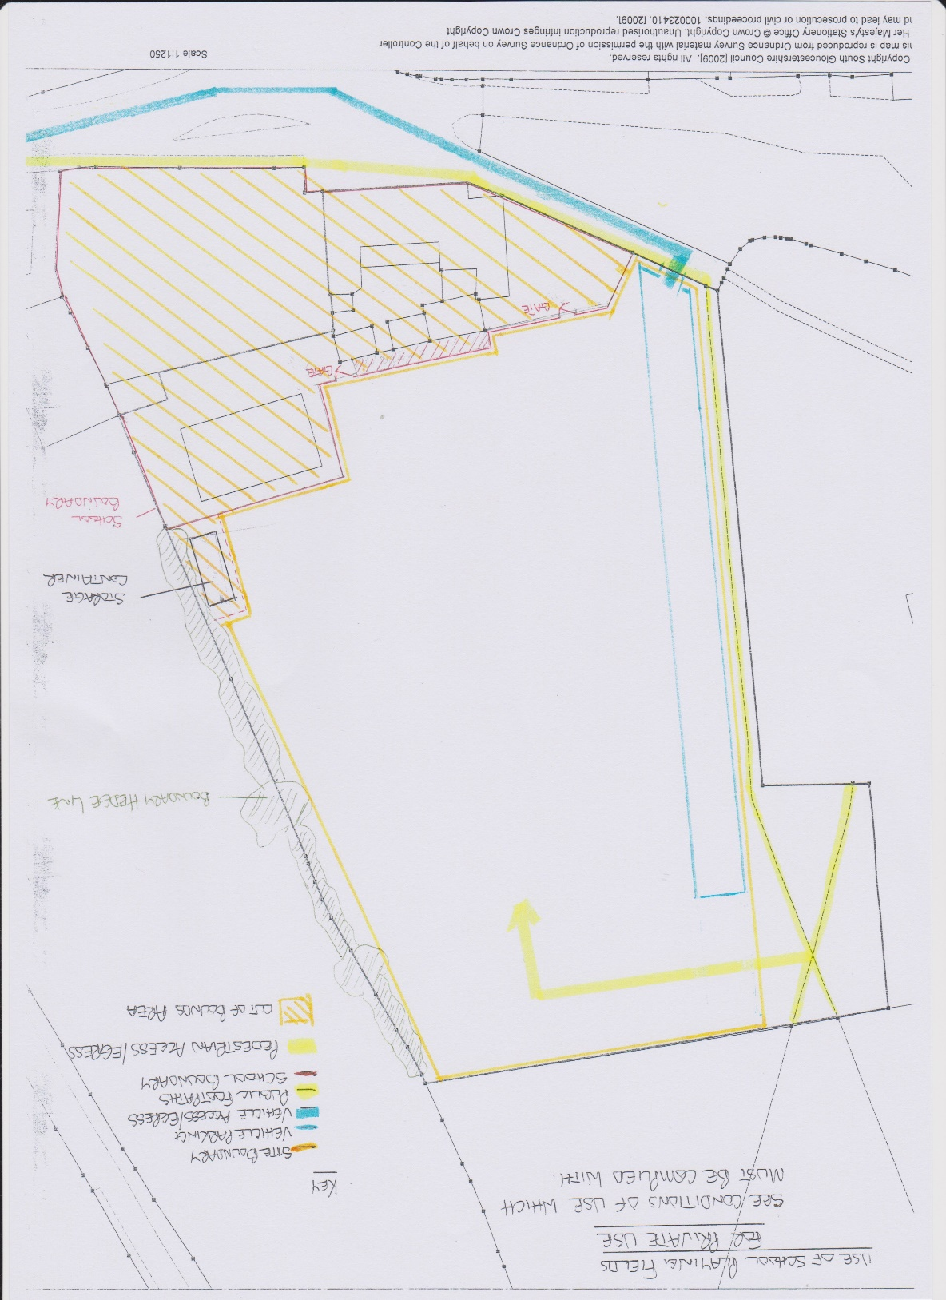
BOOKING FORM FOR USE OF SCHOOL FIELD, CROMHALL
Lead Organiser
Name of Lead Organiser
Name of Group/Organisation (if applicable)
Address (for correspondence)
Email address
Contact phone number
Event details
Requested date(s) of hire
Event timing (of the actual event) | Start time:  Finish time:
Access required (for setting up and clearing away) | Access from time:  Access until time:
Type of event
Purpose of event
Approximate number of people attending
Licensing, insurance and permissions
We will be selling tickets to the public | Yes/No
We will be playing music | Yes/No
We will be selling/providing alcohol | Yes/No
We will be having a marquee | Yes/No
We have obtained relevant licenses for above* | Yes/No
We have public liability insurance for £5million** | Yes/No
We would like commercial retail such as mobile vendors, burger vans, ice cream vans etc. | Yes/No

* The playing of music and/or supply of alcohol in public places, even if during a private event, requires an Event Licence. These must be obtained from South Glos. Council (https://beta.southglos.gov.uk/apply-for-a-temporary-event-notice/.) There is a small charge. The Parish Council will need to see a copy of any Temporary Event Licence prior to the event.

** Under certain circumstances, the Parish Council may require an Indemnity Form to be signed if no insurance is in place.

Person signing to accept compliance with the above rules:

Signed: ___________________________ (Lead Organiser)
Date: ____________________________
Print Name: _______________________
If submitting the form electronically, please send from the email address given above, to confirm authentication.

All booking forms must be received 8 weeks prior to the event, to allow time for the parish council to consider the application.

Once agreed by the council, you will be contacted to confirm the dates and access times.

Please speak to Mark Daniel (Chair of Council) to arrange collection of the key. Tel: 07746 741834

